Everbridge Create Required Weekly Test Template

Create Required Weekly Test Template
- Click New Notification
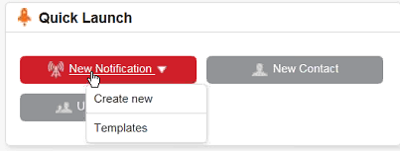
- Enter Title: Required Weekly Test
- Body Text: This is a Required Weekly Test.
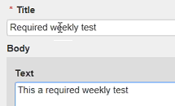
- Check the box for Save this as a message template.
- Check the box for Emergency Alert System (EAS)
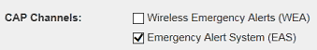
- You will select the following for the CAP Fields:
  - Message Status: Actual
  - Scope: Public
  - Message Category: Safety
  - Urgency: Immediate
  - Severity: Extreme
  - Certainty: Observed
  - Event Name: Required Weekly Test
  - Expires: 1
- Scroll up to the CAP Channels (EAS) Area to enter in your Private Key and Keystore Password.
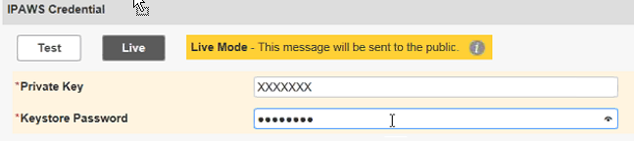
- Click the Send button at the bottom of the screen.
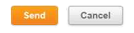
- The history will display your sent message.
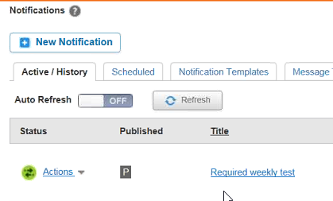

Run Weekly Test
- Click New Notification.
- Click the Use a message template link.
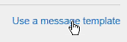
- Select the Required weekly test the message template window. Click OK.
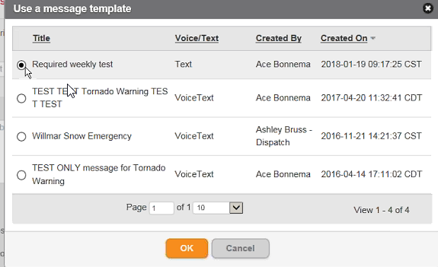
- Check the box for Emergency Alert System (EAS)
- Click the Live button in the IPAWS Credential area.
Enter in your Private Key and Keystore Password.
- You will select the following for the CAP Fields:
  - Message Status: Actual
  - Scope: Public
  - Message Category: Safety
  - Urgency: Immediate
  - Severity: Extreme
  - Certainty: Observed
  - Event Name: Required Weekly Test
  - Expires: 1
- Message: Click Load message text link.
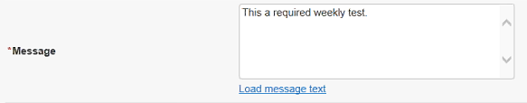
- Click the Send button at the bottom of the screen.

